
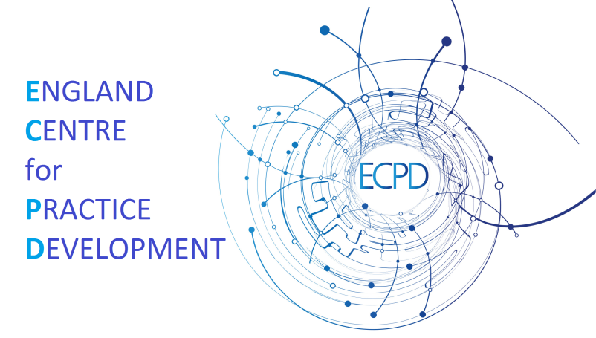

Facilitation Standards for an Integrated Approach to Workplace Learning, Development, Improvement and inquiry

Manley, K; Martin, A; Jackson, C; Wright T (2015) Developing Standards for Integrated Facilitation in and About the Workplace. Phase 2 Report: Transforming Urgent & Emergency Care Together, England Centre for Practice Development, Canterbury December
ISBN: 978-1-909067-54-7

STANDARD 1: Negotiate, agree and sustain clarity of purpose for facilitation activity at the individual, team or organisational level in the context of developing person-centre cultures and improved health outcomes
Performance Indicators:

Overall purpose:
  - Model an integrated (holistic) approach to facilitation that focuses on what matters to individuals, teams and organisations
  - Work with the individual/team, their work and workplace context
  - Relate the endpoint of facilitation practice as developing person centred cultures and ultimately improved health outcomes
Individual Purpose:
  - Enable a systematic and informed approach to personal and professional judgement to foster psychological and structural empowerment, enhance self-awareness and self-efficacy
Team Purpose
  - Work towards achieving shared workplace and practice development goals through realising a sense of security, belonging and significance
Organisational Purpose:
  - Recognise and articulate the common end purposes of facilitation practice for the organisation and its beneficiaries:
- Work based learning – in and from practice
- Practice development
- Improvement and development through growing leaders and facilitators of learning as well as positively impacting on workplace culture
- Innovation - developing and implementing new ideas
  - Accommodate less prominent purposes relevant
to the organisation:
- Knowledge translation- implement new knowledge or theory in practice
- Skills development– developing new skills, confidence and competence
- Inquiry- explore meanings and develop understanding
  - Articulate the interdependence between effective facilitation of individuals, teams and the organisation and improving care for people
STANDARD 2: Optimise the external enablers and values necessary for successful facilitation practice
Performance Indicators:

External enablers:
  - Obtain time and active support from the wider organisation/ employer for facilitation activity
  - Develop a safe environment and learning culture for and with individuals and teams through:
- Agreeing ways of working, clear boundaries and responsibilities
- Building relationship that provide reciprocity, high support & high challenge and recognising others’ expertise
Facilitator values:
  - Embrace a person centred approach that models integrity mutual respect is open and non-judgmental
  - Is participative, inclusive and collaborative with humility
  - Demonstrate reciprocal learning relationships; sharing information, vulnerability, celebrations and understanding
  - Is adaptable, flexible and responsive to individuals’ style of learning and motivation
STANDARD 3: Draw on the qualities necessary to build effective relationships for facilitation practice

Performance Indicators:
  - Understand the requirements of working at different levels - individual’s teams and organisations
  - Use empathy, realism/pragmatism being person centred
  - Inspire, be enthusiastic, use humour with the attributes of a transformational leader
  - Work with uncertainty being reflexive to the needs of the group /individual and context (including political)
  - Has credibility, practical knowledge and understanding of theory underpinning facilitation approach used
  - Is courageous and resilient with integrity to develop a safe environment
  - Use critical thinking and reflexivity
STANDARD 4: Demonstrate the skills required for integrated facilitation practice in health & social care

Performance Indicators:
  - Be participative, inclusive and work across different learning styles, boundaries, connecting with complexity
  - Know self, emotional intelligence, being reflective, continuing to learn and grow
  - Demonstrate active listening, skilled questioning and observing
  - Enable experiential learning by helping others to explore, reflect and review
  - Provide high support and high challenge, give and receive feedback
  - Use reflective inquiry, problem solving and critique with others
  - Use ethical principles in facilitation practice
  - Identify political drivers, risks and consequences, influencing, negotiating and networking to make positive connections within the organisation
  - Celebrate and recognise achievement
STANDARD 5: Commence the facilitation journey with confidence at different starting points depending on where individuals and teams are at

Performance Indicators:
  - Explore specific culture and contexts collaboratively and holistically taking into account stakeholders’ perspectives and priorities
  - Identify what matters to the people who are being supported through facilitation by starting where they are at
  - Develop a shared understanding and purpose or agreed focus through for example; clarifying values and beliefs
  - Identify the inquiry focus around implementing changes/ evidence/ innovations
STANDARD 6: Use common strategies appropriately for effective facilitation practice

Performance Indicators:
- Establish effective relationships for reciprocal and negotiated learning
- Enable experimentation and informed and supported risk taking
- Enable participation, open communication and offering practical support and encouragement
- Create a reflective space, enabling self-reflection, sense making and reflective reviews
- Develop and sustain effective ways of working knowing when to stop and review working with principles of what works well
- Enhance individual and group independence and autonomy
- Give and receive high challenge and high support
- Support practice, observation and self-assessment
- Recognise and praise effort using real time feedback to develop learning in a deliberate way
- Analyse and report on the processes of inquiry, allowing specific detail of the change to emerge over time and in response to the local environment
- Attend to the process and the goal rather than being outcome orientated i.e. learning to learn
- Strengthen capabilities and skill set to match goals, practice frameworks, policy and vision
- Critique practical and theoretical knowledge drawing on a variety of sources of evidence, experiences and perspectives
- Use creative methods
- Use different theoretical dispositions to impact on facilitation processes used (See knowledge and understanding)
- Use available time effectively
STANDARD 7: Monitor and maintain effective facilitation practice using a range of methods

Performance Indicators:
  - Critically reflect in the moment and following facilitation practice
  - Obtain formal or informal individual/ group and/ or stakeholder feedback
  - Review the safety of the learning environment/ culture
  - Review field notes and preparatory work
  - Review group’s perceptions/self-assessment of group functioning (e.g. hierarchy, co-operation or autonomy)
  - Review the level of support and challenge experienced
  - Demonstrate reciprocal learning relationships; sharing information, vulnerability, celebrations and understanding
  - Is adaptable, flexible and responsive to individuals’ style of learning and motivation
STANDARD 8: Evaluate and evidence process outcomes, intermediate outcomes and impact that individuals or teams may experience using a range of approaches

Performance Indicators:
  - Recognise and evidence a range of process outcomes that individuals or teams may experience e.g.:
- Increased reflexivity, self-awareness & self-efficacy
- Effective ways of working demonstrated by engagement, autonomous learners, self-directing leaders and goal achievement
- Role clarity and skills that enable others to be effective (growing capacity)
- Evidence of personal and professional development (including formal/accredited learning)
- Evidence of improved team effectiveness
  - Enable others to use and recognise indicators of outcome e.g.:
- Motivated, engaged self-directing individuals who know how to learn evidenced by increased effectiveness, action initiated leadership and development
- Measureable progress/ development that can be evidenced e.g. Improvement in patient care, tangible development and/or new insights
- Achievement of agreed goals and facilitation purpose
- Flourishing individuals & sense of wellbeing
- Individuals become more aware of organisational direction and goals
  - Use a range of strategies for identifying the impact of facilitation through:
- Review of agreed goals and records about interventions and process outcomes at different levels
- Review of learning processes/ strategies used and new insights
- Stakeholder feedback (e.g. using different approaches to stakeholder evaluation)
  - Recognise and evidence the impact of facilitation practice through:
- Motivated, engaged self-directing teams
- Flourishing curious individuals
- Effective workplace cultures and learning cultures e.g. staff retention
- Professional competence and team skill set development
- Achievement of systems/ organisational change
- Achievement of service and organisational KPIs e.g. improved patient outcomes and experience, saving money and time

Transformational leadership- enabling, challenging and stimulating, celebrating, building trust and inspiring a shared vision

